Problem Statement
A railway booking counter must calculate the ticket price for a group of passengers travelling together. The price depends on:
- the distance travelled (longer distance costs less per km),
- the travel class (Sleeper, AC 3 Tier, AC 2 Tier, AC First),
- the passenger’s age and gender (concessions for children and senior citizens),
- a reservation fee per berth.
Objectives
- Calculate the base fare using distance slabs.
- Apply a class multiplier for the chosen travel class.
- Apply age/gender-based concessions to each passenger.
- Add the reservation fee (free infants get no berth, so no fee).
- Show a passenger-wise fare table with a grand total.
- Calculate the cancellation penalty and refund for each passenger.

Assumptions

Distance | Rate per km
First 100 km | ₹1.00
Next 200 km (101–300) | ₹0.80
Above 300 km | ₹0.60

Class | Fare multiplier | Reservation fee | Cancellation clerkage fee
SL (Sleeper) | 1.0 | ₹20 | ₹120
3A (AC 3 Tier) | 2.2 | ₹40 | ₹180
2A (AC 2 Tier) | 3.0 | ₹50 | ₹200
1A (AC First) | 4.5 | ₹60 | ₹240

Passenger | Concession
Age below 5 | 100% (free, no berth)
Age 5–11 (child) | 50%
Woman aged 58+ | 50%
Man aged 60+ | 40%
Others | 0%

Time before departure | Penalty
48 hours or more | Flat clerkage fee (never more than the fare)
12 to 48 hours | 25% of fare
4 to 12 hours | 50% of fare
Less than 4 hours | 100% of fare (no refund)

Algorithm
- Read the passenger list, travel class and distance.
- Base fare: go through each slab and add (km in that slab × slab rate). If the result is below ₹30, use ₹30.
- For each passenger:
  - Class fare = base fare × class multiplier.
  - Find the concession % from age and gender.
  - Fare after concession = class fare − (class fare × concession %).
  - If concession is 100%, reservation fee = 0, otherwise the class reservation fee.
  - Passenger total = fare + reservation fee.
- Grand total = sum of all passenger totals.
- On cancellation: for each passenger, pick the penalty by the hours rule, then Refund = fare − penalty (never below 0). The reservation fee is not refunded.
- Print the fare table, grand total and refund table.
Pseudocode
CONSTANTS: SLABS, CLASSES, MIN_FARE = 30

FUNCTION base_fare(distance):
fare = 0, previous_limit = 0
FOR each (limit, rate) in SLABS:
IF distance > previous_limit:
km_in_slab = MIN(distance, limit) - previous_limit
fare = fare + km_in_slab * rate
previous_limit = limit
RETURN MAX(fare, MIN_FARE)

FUNCTION concession(age, gender):
IF age < 5 RETURN 100
IF age <= 11 RETURN 50
IF gender == F AND age >= 58 RETURN 50
IF gender == M AND age >= 60 RETURN 40
RETURN 0

FUNCTION passenger_fare(p, class, distance):
class_fare = base_fare(distance) * multiplier[class]
percent = concession(p.age, p.gender)
fare = class_fare - class_fare * percent / 100
IF percent == 100: reservation = 0 ELSE reservation = res_fee[class]
RETURN fare, reservation, fare + reservation

FUNCTION penalty(fare, class, hours):
IF hours >= 48: RETURN MIN(clerkage[class], fare)
IF hours >= 12: RETURN 0.25 * fare
IF hours >= 4: RETURN 0.50 * fare
RETURN fare

MAIN:
FOR each passenger: compute fare details
grand_total = SUM of passenger totals
PRINT table and grand_total
IF cancellation requested:
FOR each passenger:
refund = MAX(fare - penalty(fare, class, hours), 0)
PRINT refund table

Test Cases
# | Input | Expected result | What it tests
1 | Distance 0 or 1 km | Base fare = ₹30 | Minimum fare
2 | Distance 50 km | ₹50.00 | Within the first slab
3 | Distance 100 km | ₹100.00 | Slab boundary
4 | Distance 101 km | ₹100.80 | Crossing into slab 2
5 | Distance 300 km | ₹260.00 | Second slab boundary
6 | Distance 450 km | ₹350.00 | All three slabs together
7 | 3A, 450 km, adult age 35 | Fare 770 + 40 = ₹810 | Class multiplier (350 × 2.2)
8 | Child age 8 | 50% off fare, fee charged | Child concession
9 | Infant age 2 | Total ₹0, no reservation fee | Free travel
10 | Man age 65 / Woman age 60 | 40% / 50% off | Senior concessions
11 | Man age 59 | No concession (adult) | Age boundary
12 | Cancel 72 h before, adult | Penalty ₹180, refund ₹590 | Flat clerkage fee
13 | Cancel 24 h before, adult | Penalty 25% of 770 = ₹192.50 | 25% rule
14 | Cancel 6 h before, adult | Penalty 50% of 770 = ₹385 | 50% rule
15 | Cancel 2 h before | Refund ₹0 | No refund rule
16 | Cancel exactly 48 h / 12 h / 4 h before | Falls in the earlier-hours rule (≥ is used) | Boundary hours
Output
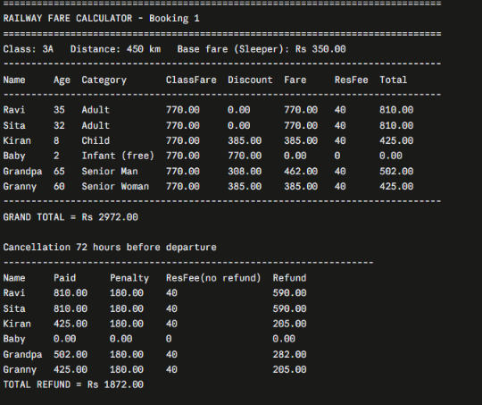

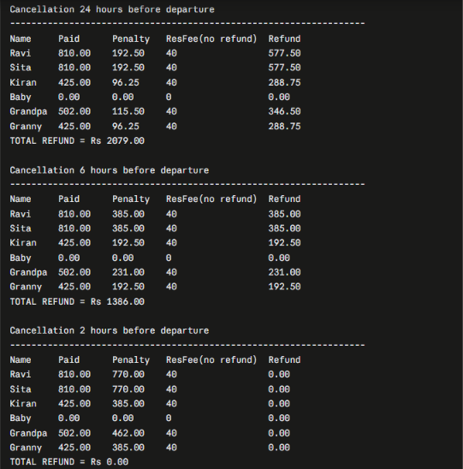

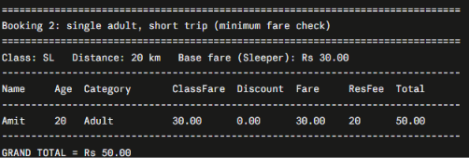

Flowchart
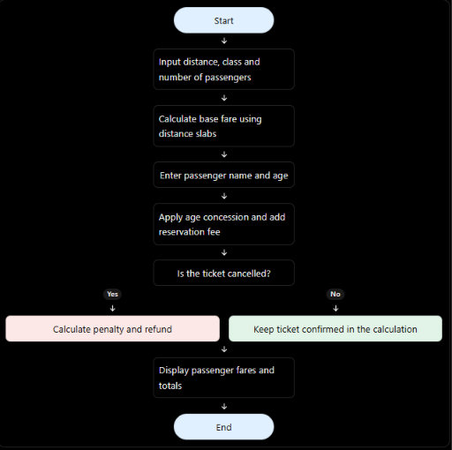

Conclusion
The calculator combines four ideas: slab-wise distance fares, class multipliers, age-based concessions and a time-based cancellation penalty. Each passenger is calculated separately, so mixed groups (adults, children, seniors, infants) are handled correctly. All rates sit in constants at the top of the program, so the railway can change policy without touching the logic.

